Multilingual Bibliography Project

**Software User Manual**

Submitted by:-

**Group I**

Arushi Jain (160001008)

Ashish Arun Gawai (160001009)

Biplab Kumar Sahoo (160001015)

Kritik Sharma (160001031)

Pushpendra Kumar (160001046)

Tatavarthy Venkat Nikhil (160001058)

Contents:

1. Installation Instructions
2. Setting up the Software and Database
3. Running the Software
   1. Login/ Sign up
   2. Search
   3. Viewing Text Details
   4. Bookmarks
   5. Search History
   6. Recommendations
   7. Trending
   8. Adding New Texts
   9. Admin Privileges

HOW TO INSTALL THIS SOFTWARE

1. To install this software you need to have following softwares installed in your system:
   1. MySQL
   2. Local Host/ Server
   3. Laravel installed via Composer (Follow instructions here: <https://laravel.com/docs/5.3> )
2. Install these softwares in the above order.
3. After the installations are done, copy the project folder in C:\Users\’YourUsername’ location

For further details, follow this video: <https://laracasts.com/series/laravel-from-scratch-2017>

HOW TO SETUP THE SOFTWARE AND THE DATABASE

1. Open the project folder and edit the .env file. Replace username with your MySQL username and password with your MySQL password.
2. Create a database named library and then download db.sql file.
3. Import db.sql in Phpmyadmin.
4. Now open your command prompt.
5. Move to project directory (Type ‘cd project’ without quotes).
6. Type php artisan serve.
7. A message will be displayed saying Laravel development started at localhost:8000
8. Open your browser and type localhost. You can see the homepage of your website now.

HOW TO RUN THIS SOFTWARE

# 1. Login/Signup

* 1. Sign up if you are not a registered user on the website.
  2. Sign in using your credentials if you are already registered.

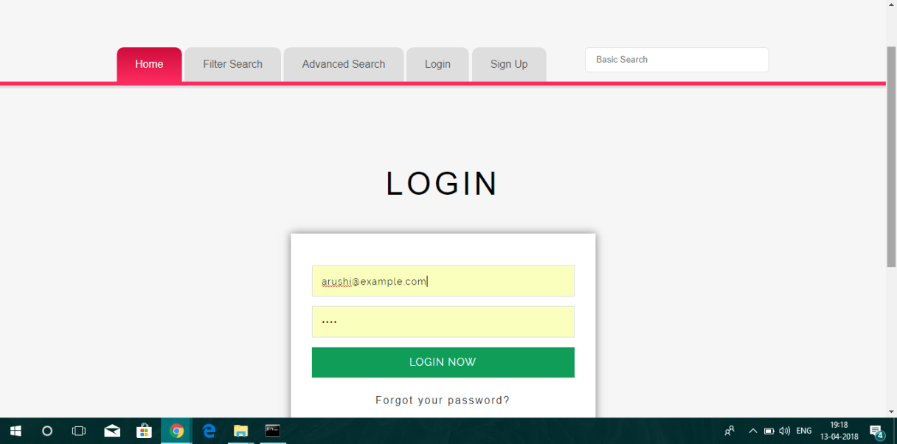

# 2. Searching for texts

1. Basic Search: Enter anything you want to search for
   * 1. You will get the citations of all the results that match with your search sorted by relevance.
     2. Click on sort by most popular if you want to see the popular results first.
2. Search Filter: Search by book title or author or publisher or genre or language or translation (You can enter data in more than one fields)

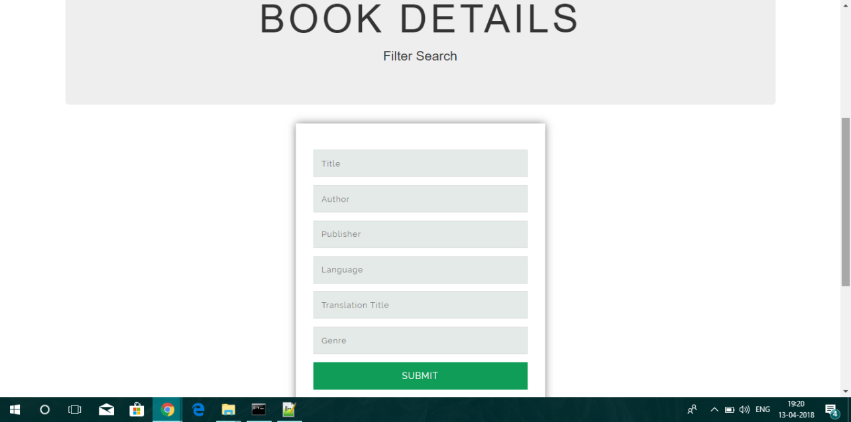

1. Advanced Search: Use the and/or/not columns while entering keywords to search for in specific fields.

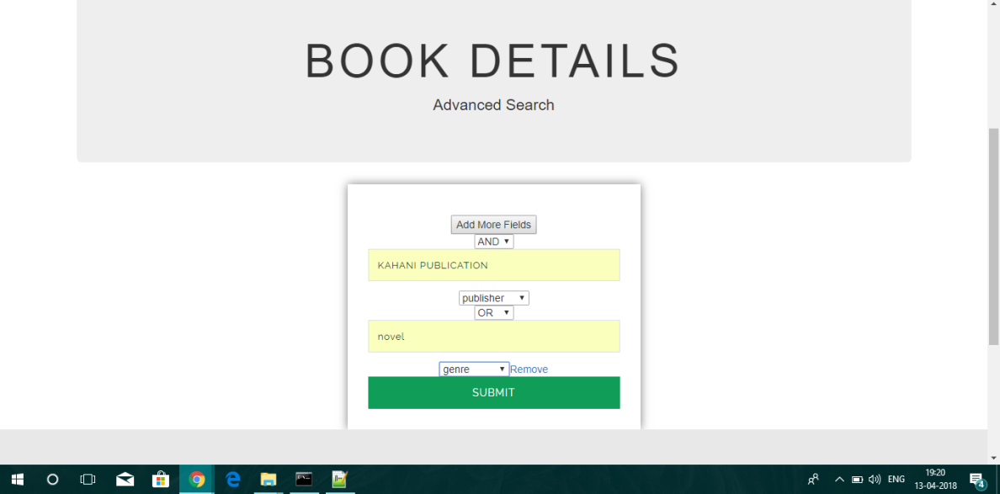

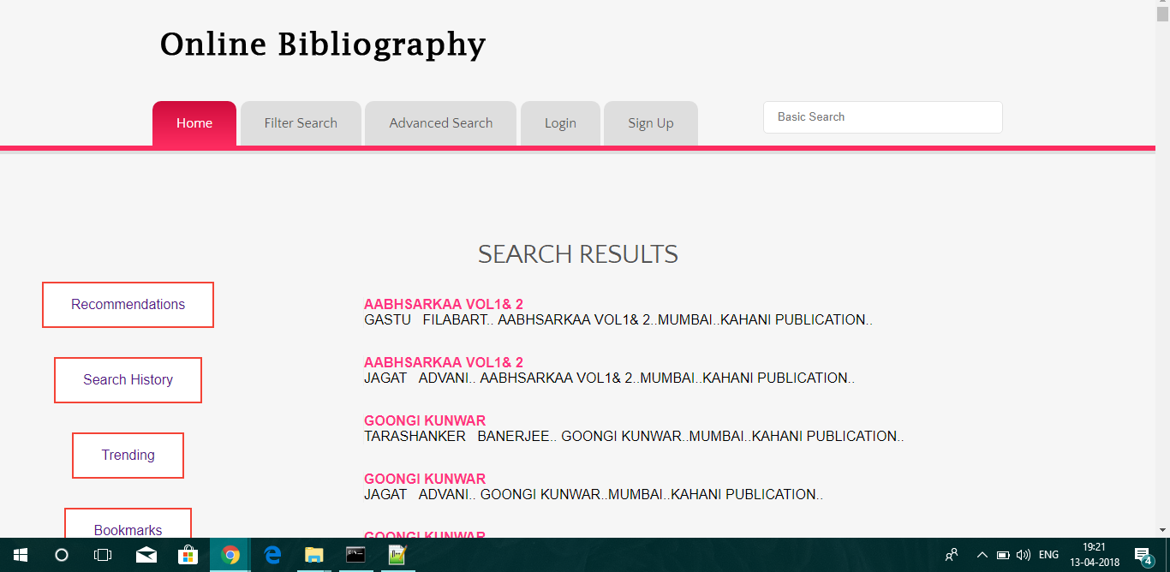

3. **Viewing a specific Text**

* 1. Click on the specific search results whose details you want to view.
  2. You will see the details of the selected text along with comments from other users about the texts.

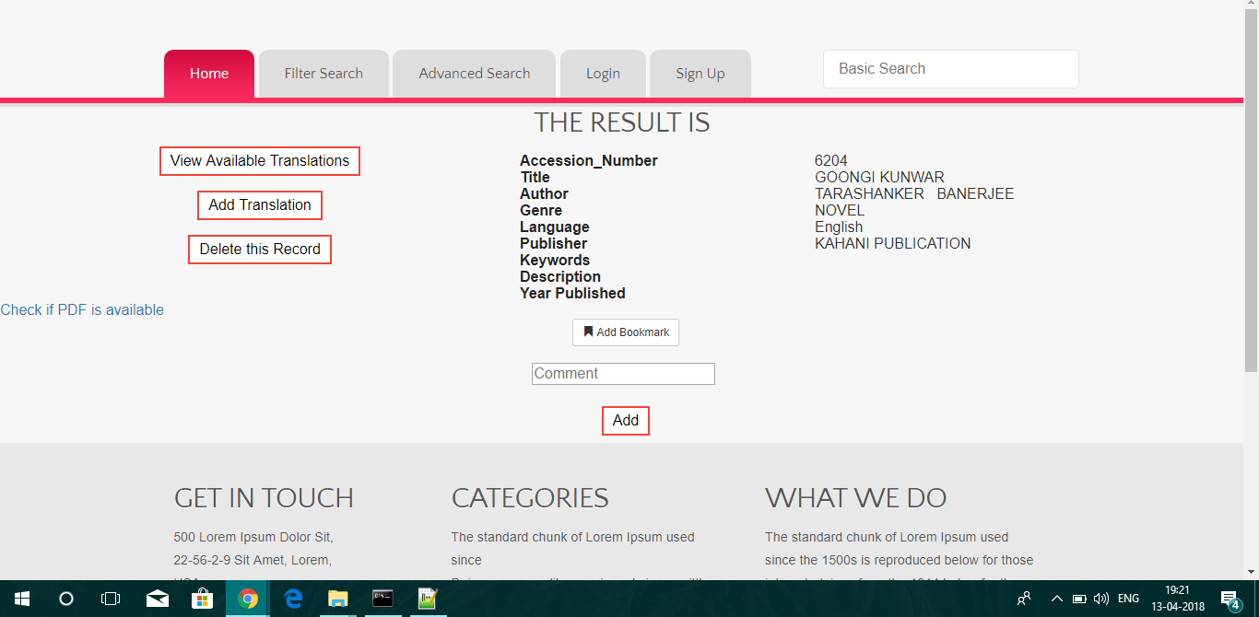

* 1. You can download the attachment if the text if it is available.
  2. You can click on Bookmark to bookmark that specific result for handy reference in future. To remove from bookmarks, click on that button again.
  3. You can also add a comment about the texts.
  4. Click on view translations to see if any translations for the given text are available.
  5. If the translations are available, you will see the translations and transliterations of the given book and their texts if available.

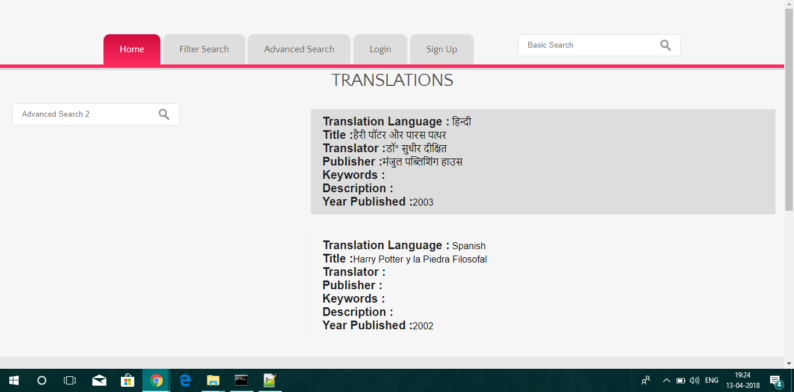

# 4. Viewing bookmarks

1. Click on Bookmarks tab to view bookmarks.
2. If you are not logged in, you will be redirected to the login page.
3. You will see all your bookmarks sorted from most recent.
4. You can click on any particular bookmark to view its details
5. You can also remove Bookmark from a text by clicking remove from Bookmarks.

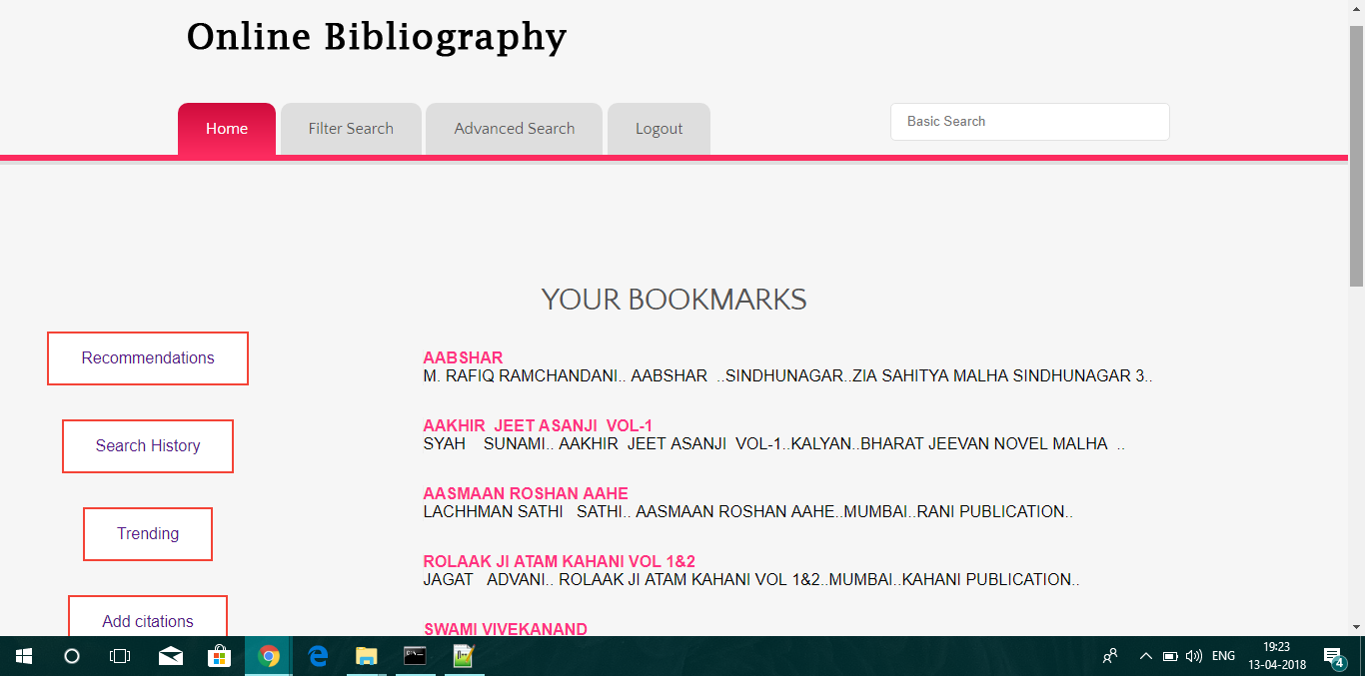

5. **Viewing search History**

1. Click on History tab to view your search history (It will only show you the texts whose details you have viewed).
2. If you are not logged in, you will be redirected to the login page.
3. You will see all your history sorted from most recent.
4. You can click on any particular record to view its details
5. You can also remove a record from history by clicking remove from History.
6. You can also click on Clear all to empty your search history (It is recommended to clear your history after every 200 searches.)

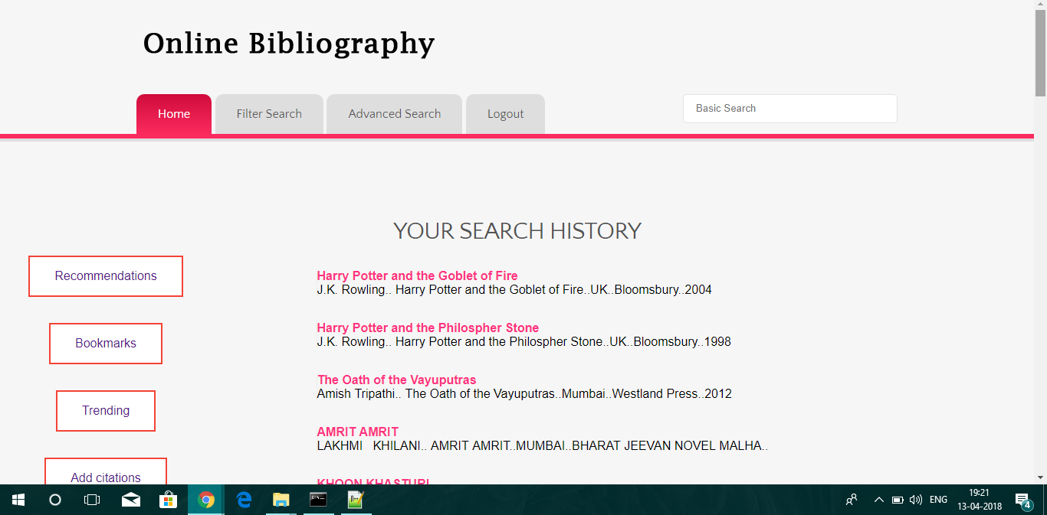

1. **View Recommendations**
2. Click on Recommendations tab to view personalized recommendations for you.
3. If you are not logged in, you will be redirected to the login page.
4. You will see top 10 recommendations for you based on your bookmarks and search history.
5. You can click on any particular recommendation to view its details

1. **View Trending**
2. Click on Trending tab to view top 10 trending texts.
3. You can click on any particular text to view its details
4. **Add new texts**
5. If you have citations available for a particular text/translation, you can add them to the database.
6. For adding a text, click on the “add new text” tab.
7. For adding a translation, click on the “add new translation” option that you see after viewing the details of that particular text.
8. Your request will be submitted to the admin for review.

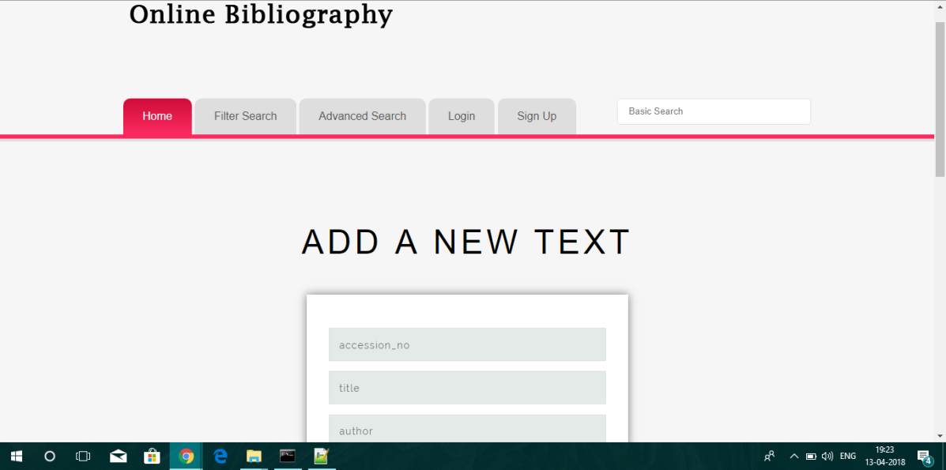

1. **Admin privileges**
2. Viewing pending requests for new records: You can review pending requests and insert them to the database. You can also delete that request if you want.
3. Deleting records from the database: When you view a specific record detail, you will get an option to delete that particular text.